Cincinnati Goes Red All Year Round

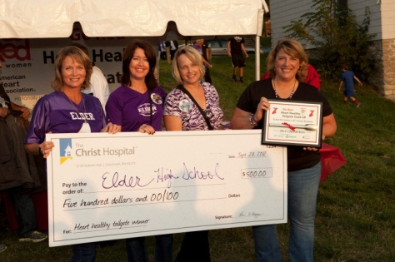
Elder/St. Xavier Heart Healthy Tailgate
The third annual Elder/St Xavier healthy tailgate cook-off took place this fall.
In a challenge from The Christ Hospital and the American Heart Association,
the schools created heart healthy meals that met American Heart Association nutritional guidelines.
For the second year in a row, Elder won the contest, making the score: Elder- 2/St. Xavier -1.
Elder received a $500 scholarship for their school, presented by The Christ Hospital.

Go Red Girl Scout Patch Program
The Christ Hospital and the American Heart Association created the
Go Red Girl Scout Patch program to educate young girls about their hearts
and how to keep them healthy. The Christ Hospital has an online program
that helps troop leaders coordinate a number of heart healthy activities.
To date, over 1,000 young girls have earned their Go Red patch.
To learn more about the Go Red Patch program,
visit www.TheChristHospital.com/goredpatch

Have Faith in Heart
Now in its third year, Have Faith in Heart has reached over 6,000 people
through churches and faith-based organizations. In partnership with
The Christ Hospital, the American Heart Association holds a series of
educational programs and workshops to teach the importance of
heart healthy living. Churches hold Red Dress Sundays to
bring the healthy message to their congregations.

